Student
- Navigate to students portal
https://azure.microsoft.com/en-us/free/students?icid=portal
- Search foundry
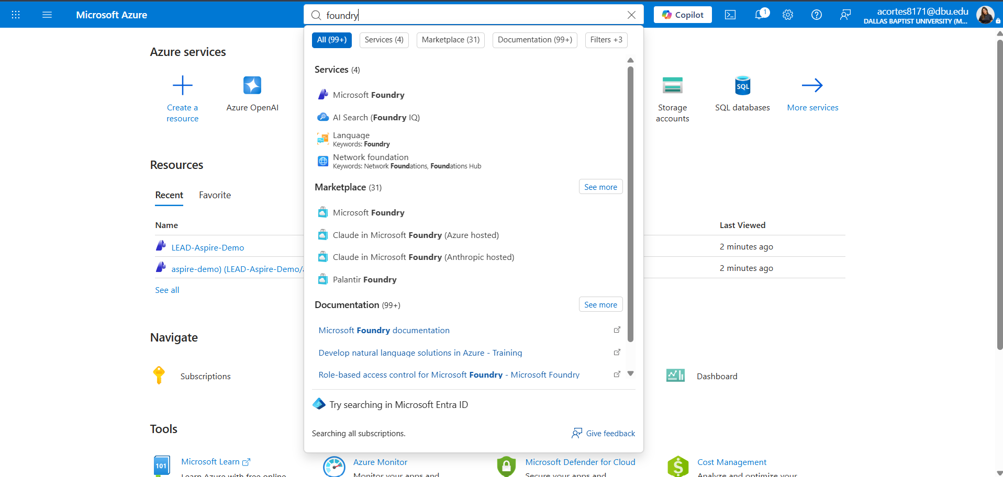
- Create in create or create a resource
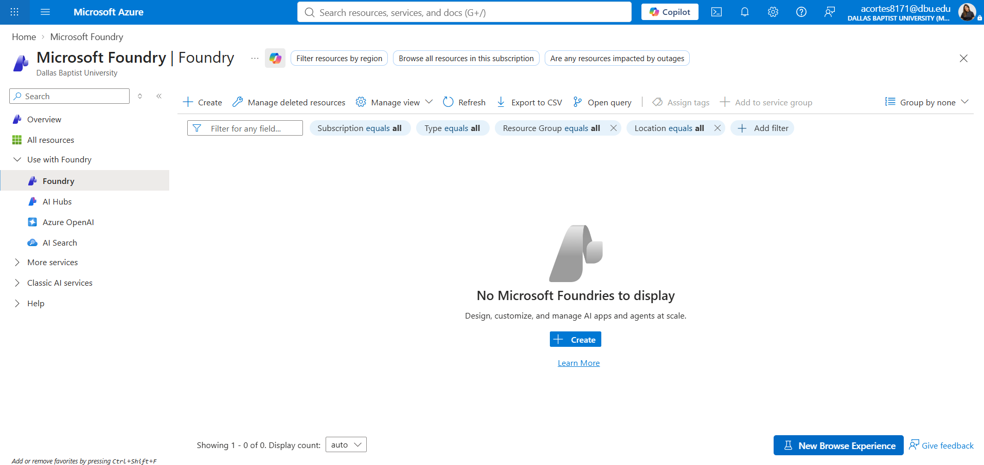

- Set the propierties example of resource group “lead”

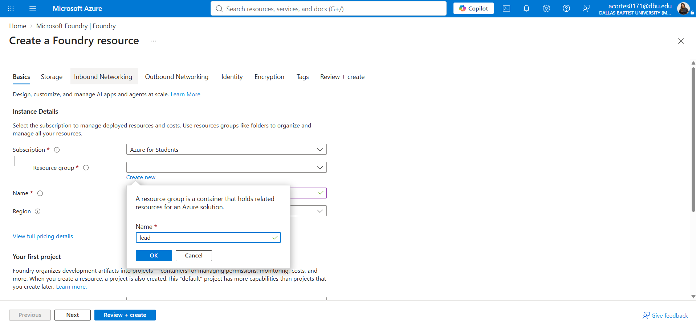
- Provide a name to your project
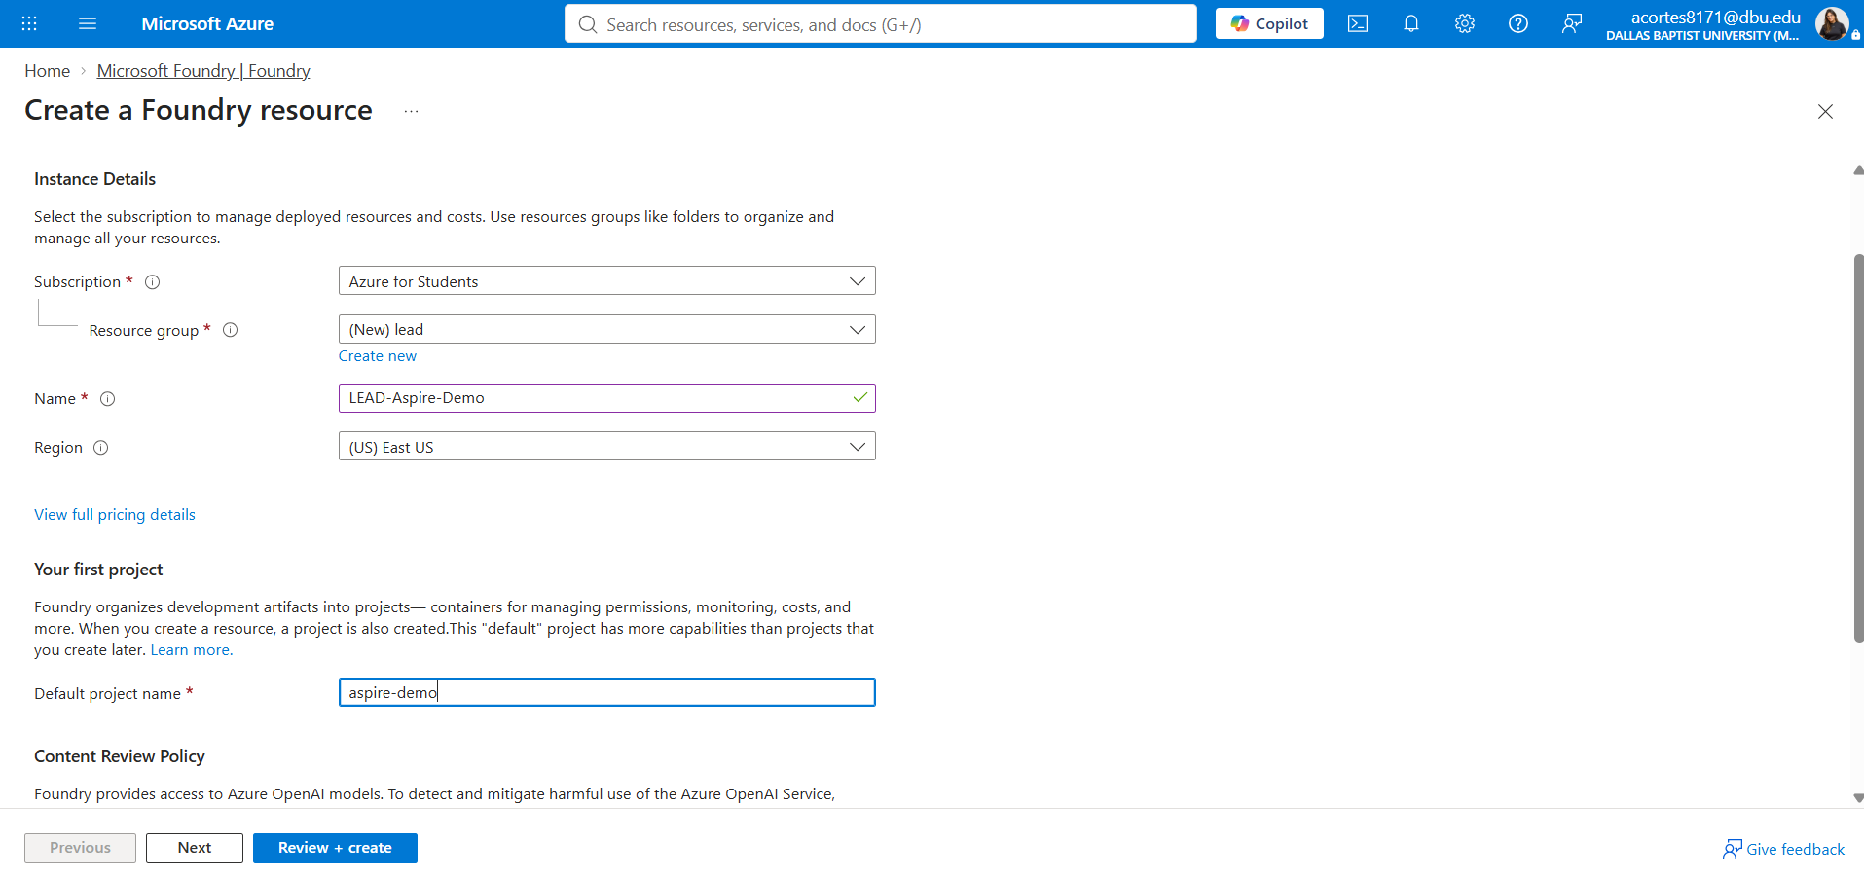
- Click in review and create (it takes a couple of minutes)
You will see this … Deployment in progress
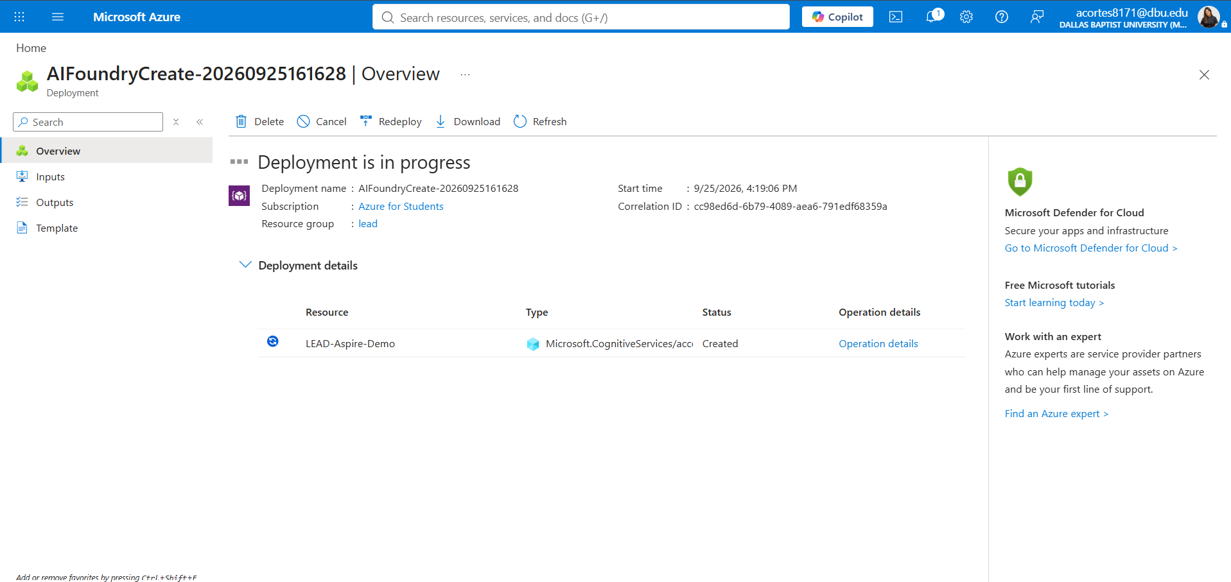
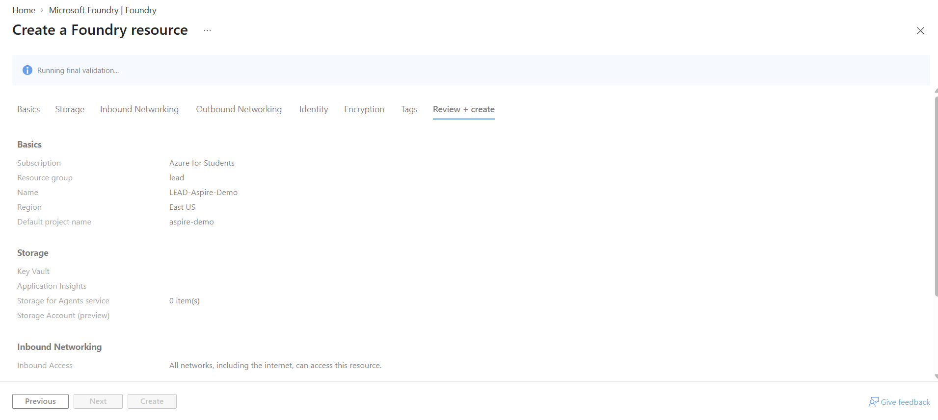

- After the deployment is completed you will see and clic Go to Foundry portal
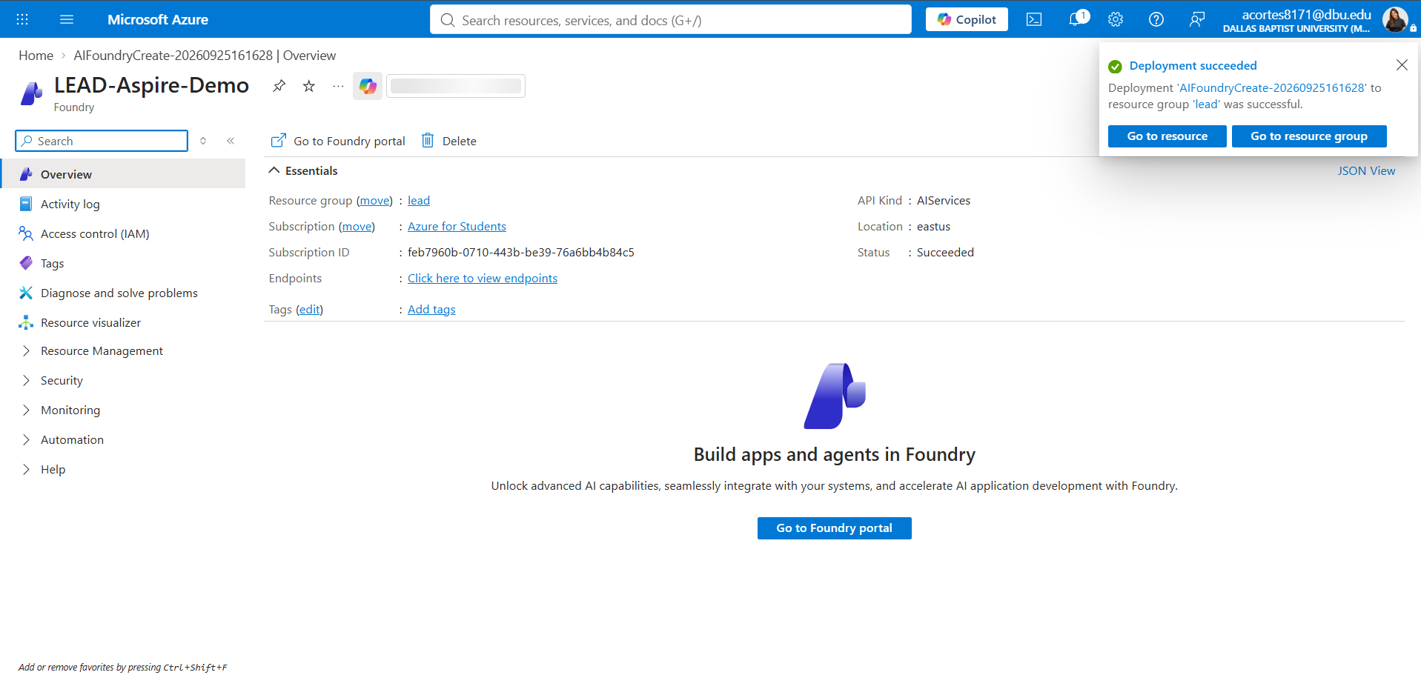

- It navigates to Foundry home portal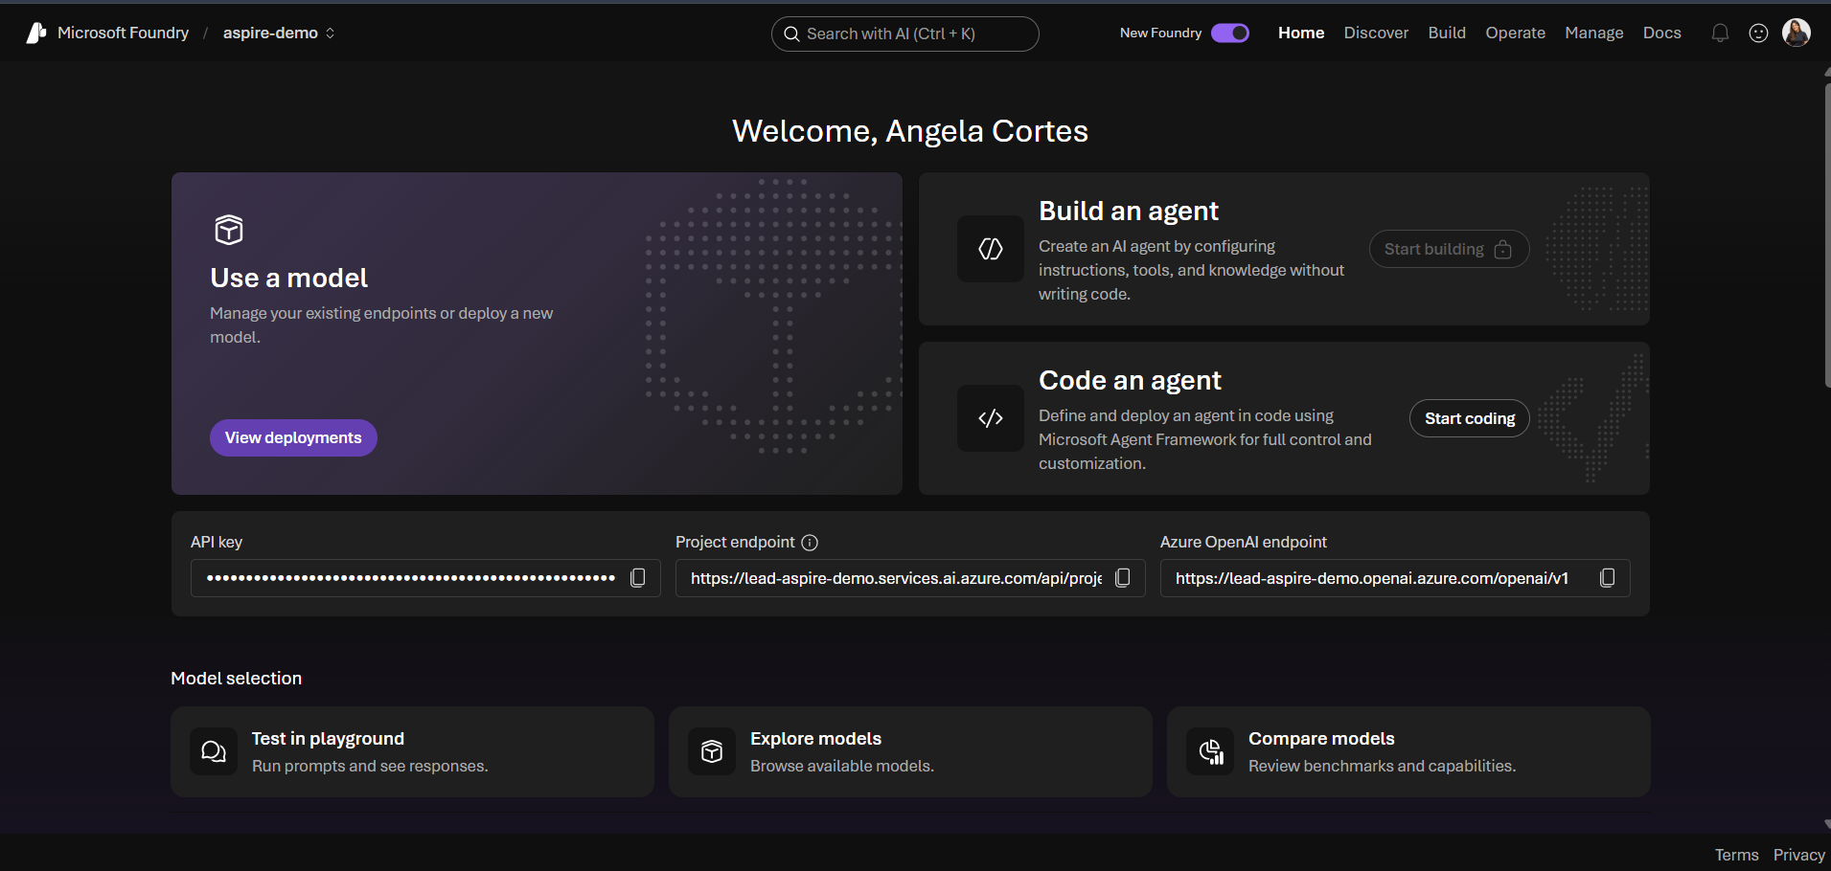

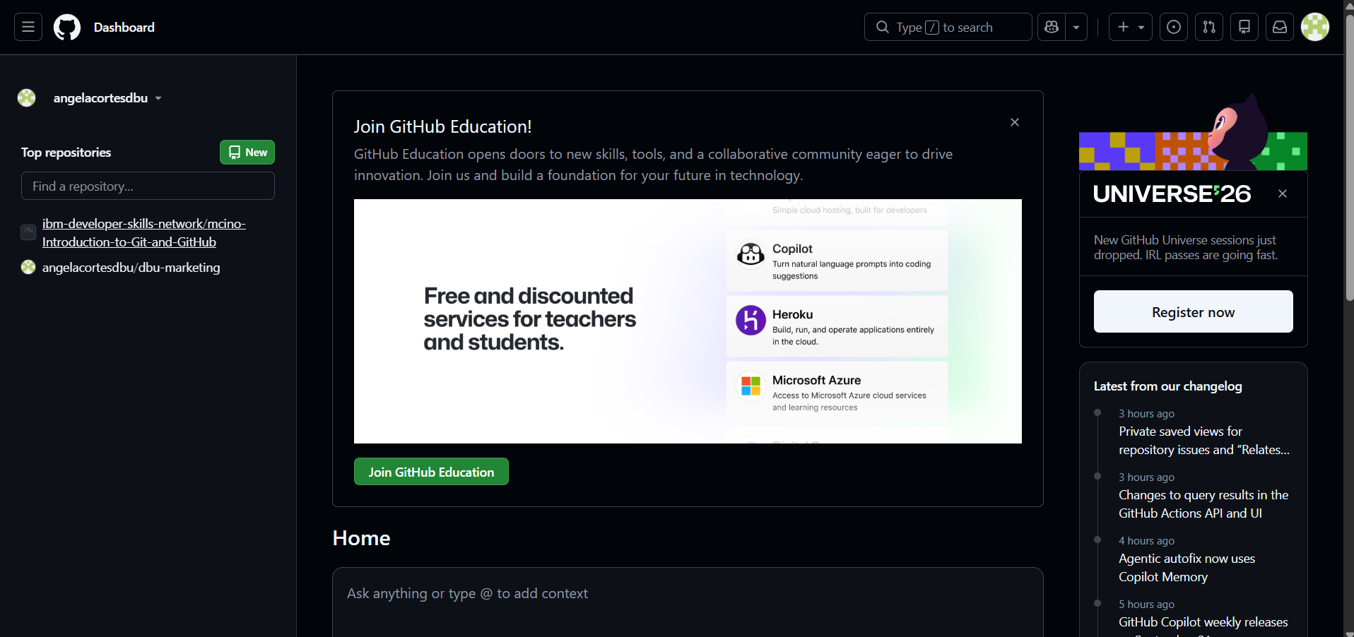
https://github.com/settings/education/benefits
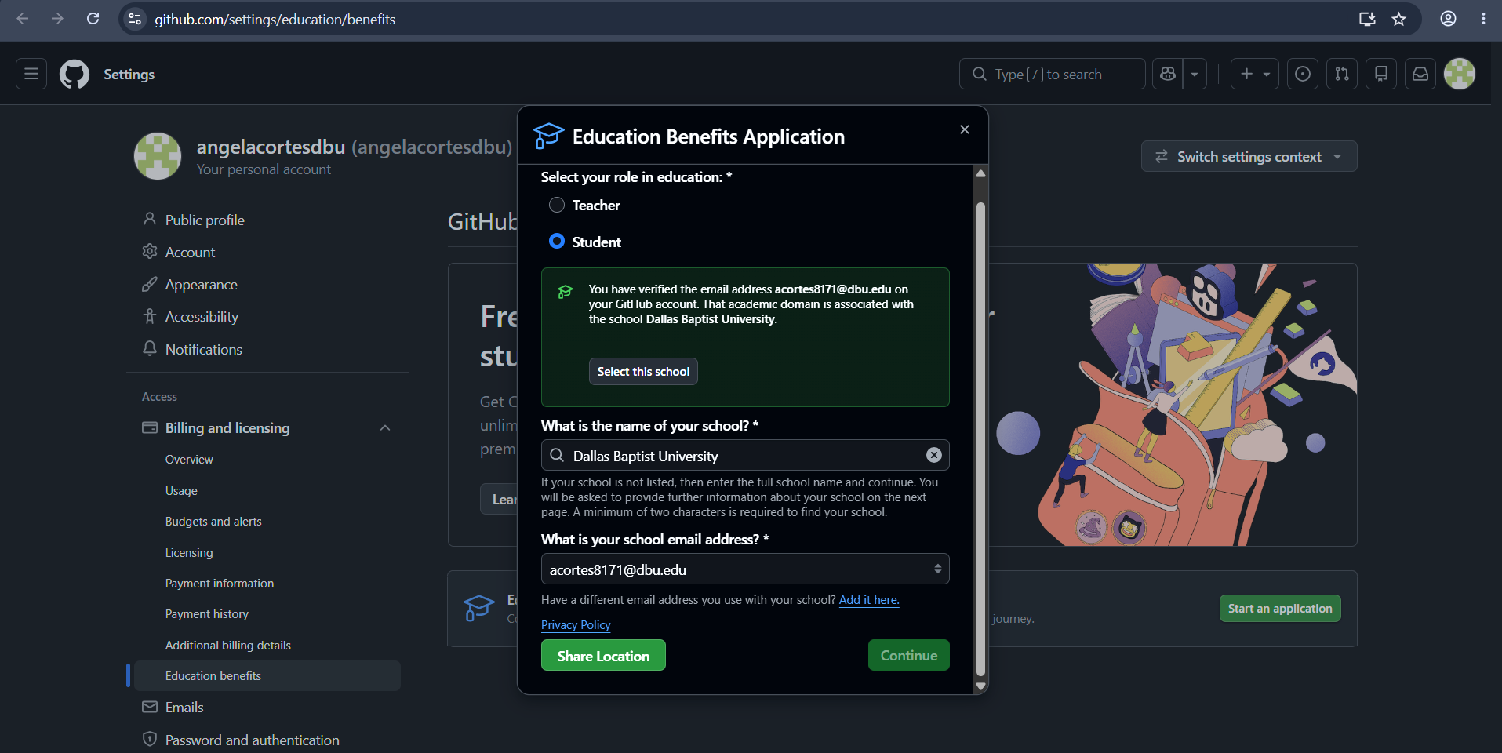
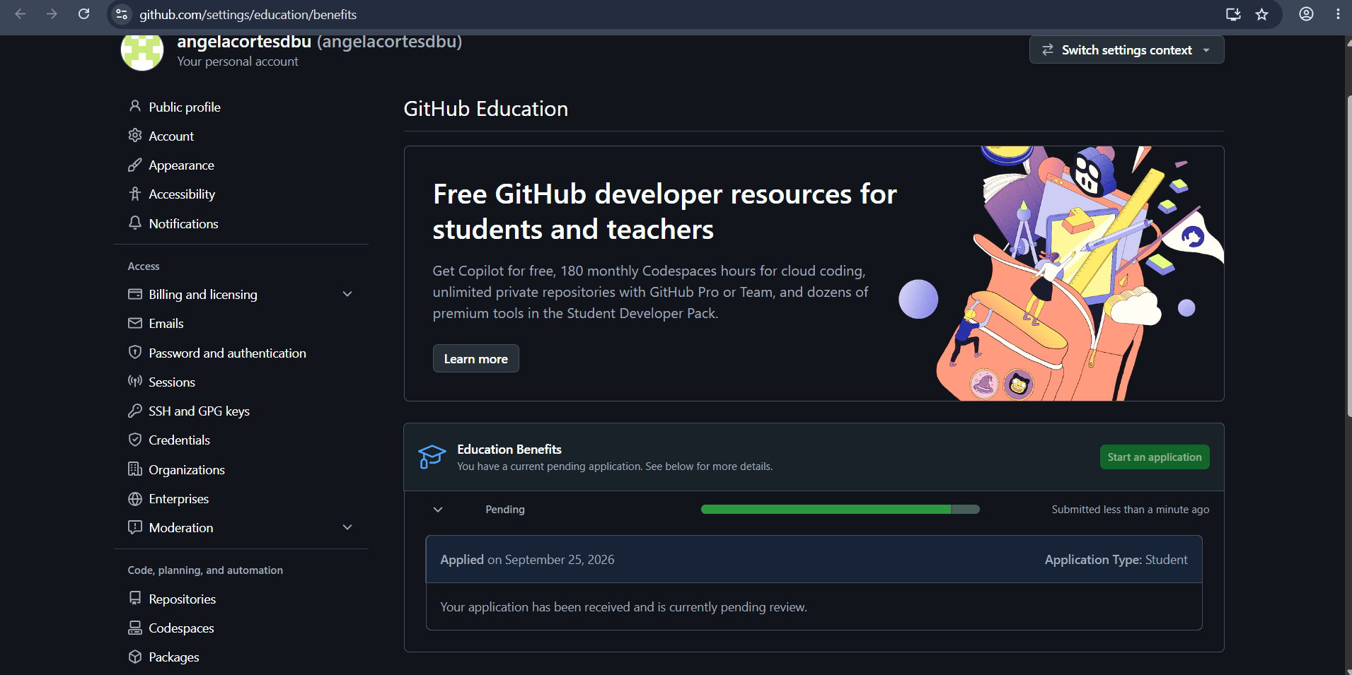
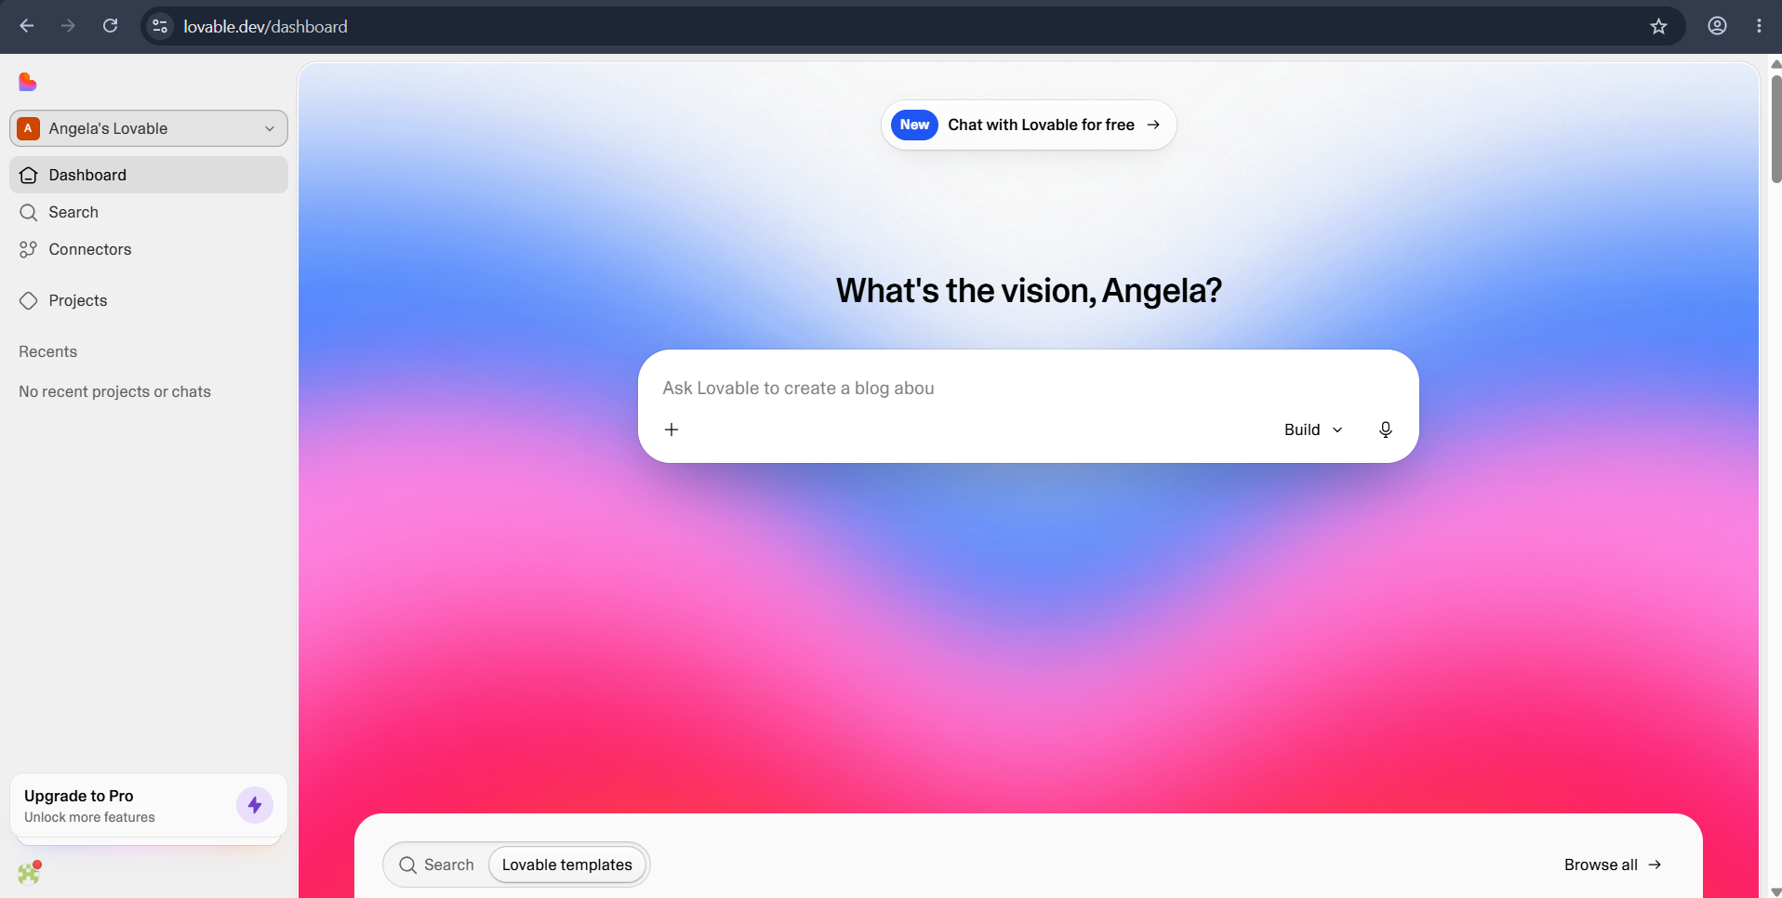
Create a modern web application called "Fraud Investigation Assistant".
Purpose:
This application helps fraud analysts investigate suspicious transactions using an Azure AI Foundry Agent.
Design Requirements:
- Professional enterprise appearance
- Inspired by Microsoft Fluent Design
- Clean dashboard layout
- Responsive for desktop and tablet
- White and blue color scheme
- Banking and financial services aesthetic
Pages:
1. Investigation Workspace
Features:
- Transaction Description input
- Transaction Amount field
- Merchant Name field
- Customer Location field
- Analyze Transaction button
2. AI Analysis Results
Display:
- Risk Score (Low / Medium / High)
- Investigation Summary
- Suspicious Indicators
- Recommended Actions
- Confidence Level
- Timestamp
Present analysis inside professional cards.
3. Investigation History
- Previous investigations
- Search capability
- Clear conversation timeline
4. Connection Settings
Fields:
- Azure AI Foundry Agent Endpoint
- Agent ID
- API Key
Save button
Technical Requirements:
- React
- TypeScript
- TailwindCSS
- Clean component architecture
- Loading states
- Error handling
- Mobile responsive
Create an API service file:
services/agentService.ts
Create a placeholder function:
async function analyzeFraudCase(transactionData)
The function should call an Azure AI Foundry Agent endpoint.
Expected payload:
{
transactionDescription: "",
amount: "",
merchant: "",
location: ""
}
Expected response:
{
riskLevel: "",
summary: "",
indicators: [],
recommendations: [],
confidence: ""
}
Environment Variables:
VITE_AGENT_ENDPOINT=
VITE_AGENT_ID=
VITE_AGENT_API_KEY=
Sample Scenario:
Transaction:
"Customer made a purchase in Dallas for $45. Ten minutes later another charge of $3,800 appeared in a different country."
Expected AI Output:
Risk Level: High
Summary:
Potential account takeover or card compromise detected.
Indicators:
- Geographic anomaly
- High-value transaction
- Impossible travel pattern
Recommendations:
- Flag transaction
- Contact customer
- Review recent activity
Confidence:
92%
Generate production-quality code and UI components.

- Click the button test in playground
- Create you own agent!
